# Rell Trader: Server Documentation

## Introduction

Rell Trader is an advanced trading system designed to monitor trade signals from multiple symbols in the forex market, place trades, and manage user funds efficiently. The system incorporates user authentication, dynamic symbol management, trade history tracking, and real-time updates to a mobile app. This documentation provides an in-depth look at the development process, challenges faced, and the solutions implemented.

## Development Process

### Setting Up the Django Environment

1. **Project Initialization:**

The project was initialized using Django, setting up a virtual environment and installing necessary packages such as Django Rest Framework (DRF), Celery, Redis, and other dependencies. This ensured a clean and isolated environment for development and easy dependency management.

1. **App Structure:**

The project was divided into several Django apps for better modularity, making the code-base easier to manage and scale:

1. users: Manages user authentication and profiles. It handles user registration, login, password management, and profile updates.
2. trading: Handles trade signals, trade placements, and trade history. It processes incoming trade signals, executes trades, and logs each trade's details.
3. symbols: Manages the tradable symbols. It allows users to add, update, or remove symbols dynamically and maintains a list of all available symbols.
4. notifications: Sends real-time updates to the mobile app. It ensures that users receive instant notifications about trade activities and system alerts.

### Core Features

1. **User Authentication:**

Implemented using a custom built authentication system, ensuring a secure and robust user authentication process. The user model was extended to include additional fields relevant to trading, such as account balance and trading preferences. Integration with Django Rest Framework allowed for API-based token authentication, enabling secure communication between the server and client applications.

1. **Dynamic Symbol Management:**

Created models and views to manage tradeable symbols dynamically. Users can add new symbols, update existing ones, or remove them from the database. This feature ensures that the system can adapt to changing market conditions and user preferences without requiring code changes or server restarts.

1. **Trade Signal Processing and Trade Placement:**

Designed a robust system to process trade signals and manage trade placements. The system listens for incoming trade signals, evaluates them based on predefined criteria, and executes trades accordingly. Each trade's data, including entry price, exit price, profit/loss, and timestamp, is saved and retrievable for every user, providing a comprehensive trade history.

1. **Real-time Updates:**

Utilized Django Channels to handle WebSocket connections and google firebase notification system for real-time updates. This allows the server to push updates to the mobile app instantly, ensuring users receive the latest information about their trades and account status without having to refresh the app manually. The notification system was designed to handle high volumes of messages efficiently, ensuring timely delivery of updates.

## 5. Push Notifications

Leveraged Firebase Cloud Messaging (FCM) to implement a robust push notification system. This feature enables real-time alerts for critical trade updates, price movements, and other relevant information. The system efficiently sends notifications to targeted users based on their preferences and subscription settings.

**How it works:**

* **Device Registration:** When a user installs the app, it generates a unique Firebase Cloud Messaging (FCM) token and securely stores it on the device.
* **Token Management:** The app sends the FCM token to the server during user authentication or registration.
* **Notification Triggering:** When a notification needs to be sent, the server utilizes the FCM API to deliver the message to the specified FCM token.
* **Message Delivery:** FCM handles the delivery of the notification to the user's device, even if the app is in the background or closed.
* **Client-Side Handling:** The mobile app receives the notification and displays it to the user, providing options for actions like opening the app or viewing the notification details.

By integrating push notifications, the application enhances user engagement and provides timely updates on critical trading information.

## Challenges and Solutions

### Challenge: Parallel Processing of Trade Signals

**Initial Approach:**

Threading was initially used to run parallel workers for checking signals and placing trades. However, this approach presented significant limitations:

* **Unreliable Execution:** Threads would sometimes stop unexpectedly, causing missed trade opportunities and potential financial losses.
* **Resource Contention:** Threads competed for system resources, leading to performance issues and bottlenecks.
* **Complexity:** Managing thread life-cycle and synchronization was complex and error-prone, increasing the risk of bugs and system instability.

**Solution: Celery and Redis**

To address these challenges, Celery, a powerful background worker built with python to perform heavy duty tasks and Redis, a very fast database, message broker that uses the ram as primary storage, were adopted for background task processing. This approach provided a more reliable, scalable, and efficient solution for handling parallel processing of trade signals and trade placements.

**Celery Setup:**

Celery was configured with Redis as the message broker to manage task queues and ensure reliable task execution. This setup allowed tasks to be distributed across multiple worker processes, ensuring efficient use of system resources and high availability.

**Task Definition and Scheduling:**

Defined tasks for processing trade signals and placing trades, ensuring each task is handled independently and efficiently. Celery was used for parallel processing, allowing the system to check for trade signals and execute trades promptly.

### Benefits of the Solution

* **Reliability:** Redis ensures reliable queuing and execution of tasks, reducing the risk of missed trade opportunities and system failures.
* **Scalability:** Celery allows for easy scaling of workers to handle increased load efficiently. As the number of users and trade volume grows, additional worker processes can be added to maintain performance.
* **Efficiency:** Background tasks run independently of the main application thread, enhancing overall system performance. This ensures the main application remains responsive, even under high load.

**Rell Trader Money Management source code**

### Imports and Initial Setup

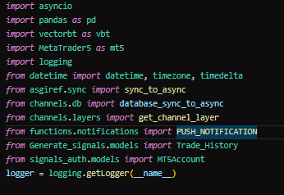

**Function:**

* Imports necessary modules and libraries.
* Sets up logging to monitor and debug the application.

### Premium_Trade Class Initialization

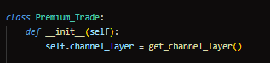

**Function:**

* Initializes the Premium_Trade class.
* Sets up the WebSocket channel layer for real-time communication.

### get_buy_or_sell_signalMethod3.13.2

### ****Function:****

* Fetches the latest market data and converts it to a DataFrame.
* Calculates moving averages (14, 50, 365) and RSI (14) indicators.
* Checks for buy or sell signals based on the conditions of the indicators.
* Sends real-time updates via WebSocket and returns the signal data.

### check_profit_or_loss Method

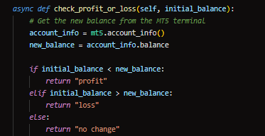

* Compares the initial balance with the current balance to determine if there was a profit, loss, or no change.

### check_open_positions Method

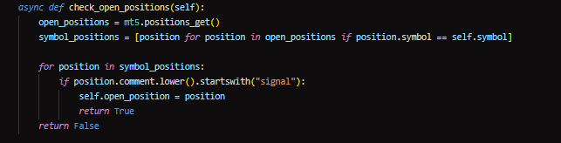

**Function:**

* Checks if there are any open positions for the specified symbol.
* Returns True if an open position with a comment starting with "signal" is found, and sets the open_position attribute.

### check_trade_history Method

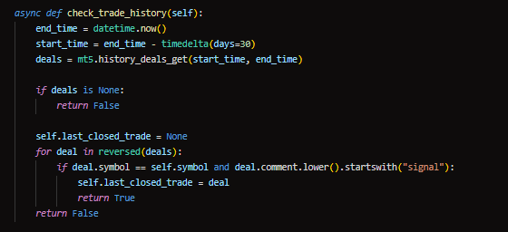

**Function:**

* Retrieves the trade history for the last 30 days.
* Checks if there are any closed trades with a comment starting with "signal".
* Sets the last_closed_trade attribute and returns True if a match is found.

### wait_for_trade_close Method

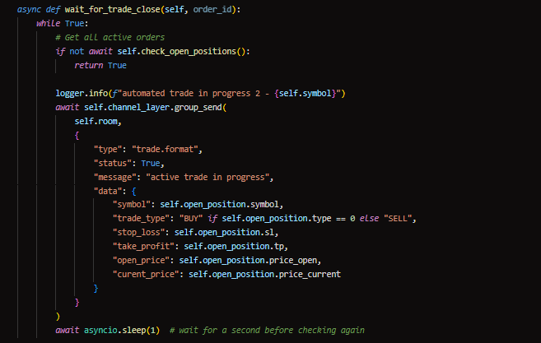

**Function:**

* Waits for a trade to close by continuously checking for open positions.
* Sends real-time updates via WebSocket about the active trade in progress.

### place_trade Method

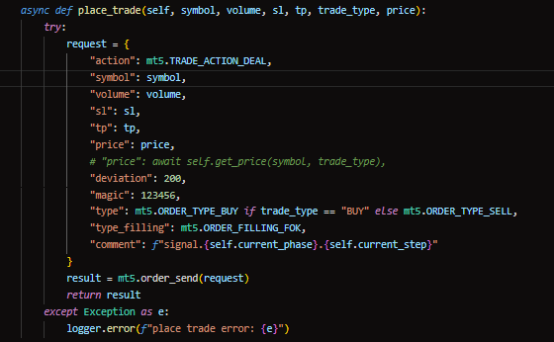

**Function:**

* Places a trade order on MetaTrader 5.
* Configures the trade request parameters including symbol, volume, stop loss, take profit, price, and trade type.
* Sends the trade request and returns the result.

### place_buy_or_sell_trade Method

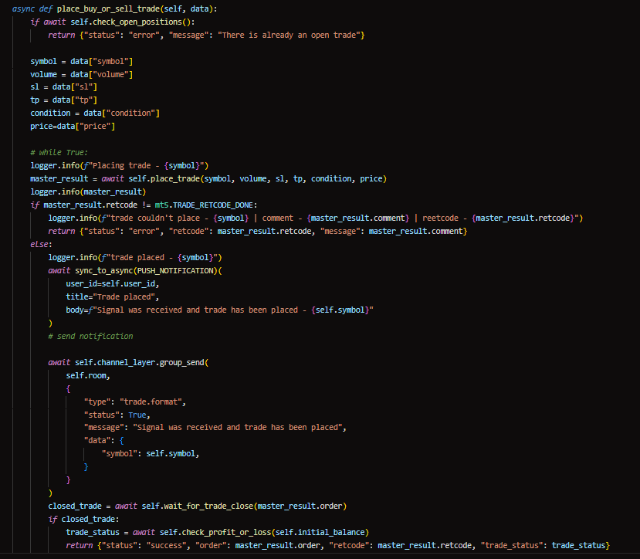

**Function:**

* Places a buy or sell trade for the master account.
* Configures the trade parameters including stop loss, take profit, and lot size.
* Places the trade and then places the same trade for all slave accounts.

### get_price Method

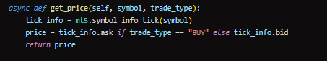

**Function:**

* Retrieves the current price for a given trade type (buy or sell).

### convert_pips_to_price Method

11

**Function:**

* Converts pips to a price value based on the symbol's decimal places.

### calculate_initial_lot_size Method

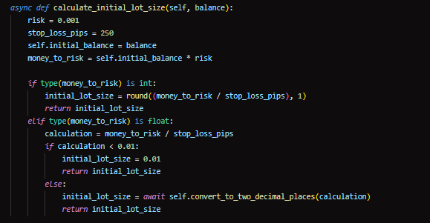

**Function:**

* Calculates the initial lot size based on the account balance and risk management.

### PHASES_DATA Method

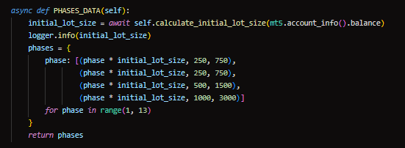

**Function:**

* Generates data for different phases of trading, including lot sizes, stop loss, and take profit levels.

### get_sl_tp_lot_size Method

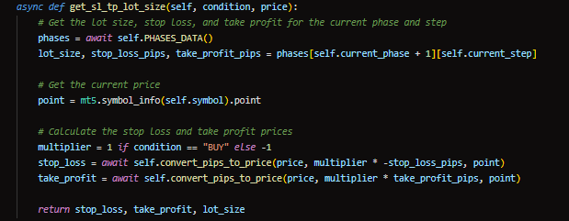

**Function:**

* Gets the stop loss, take profit, and lot size for the current phase and step based on the trade type and price.

### convert_to_two_decimal_places Method

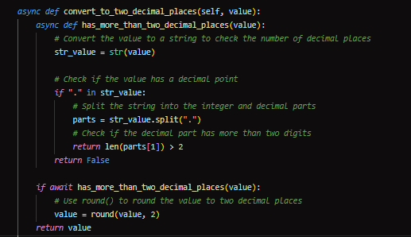

**Function:**

* Rounds a value to two decimal places if needed.

### save_to_db Method

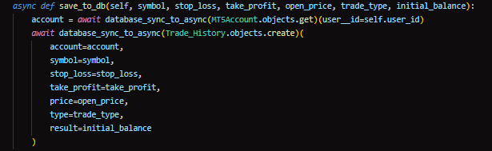

**Function:**

* Saves trade details to the database.

### adjust_phases_and_steps Method

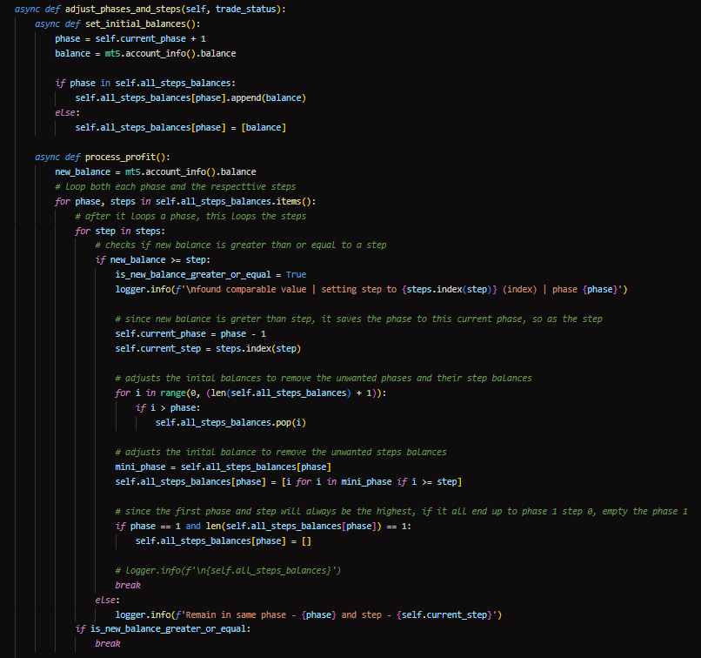

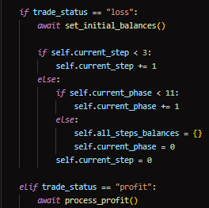

**Function:**

* Adjusts the current phase and step based on the trade outcome (profit or loss).

### shutdown_mt5 Method

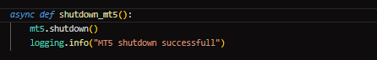

**Function:**

* Shuts down the MetaTrader 5 terminal.

### login_to_mt5 Method

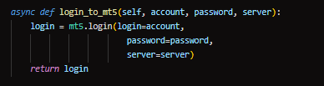

**Function:**

* Logs into the MetaTrader 5 terminal with the provided account details.

### money_management Method

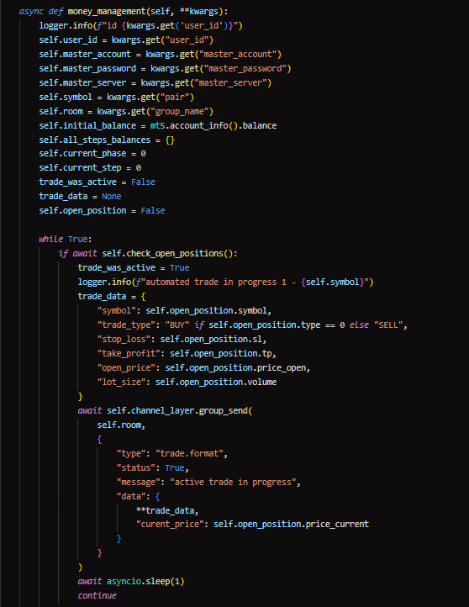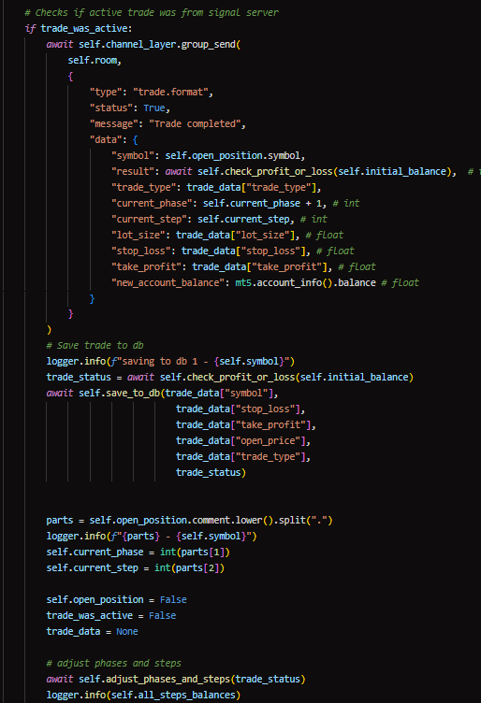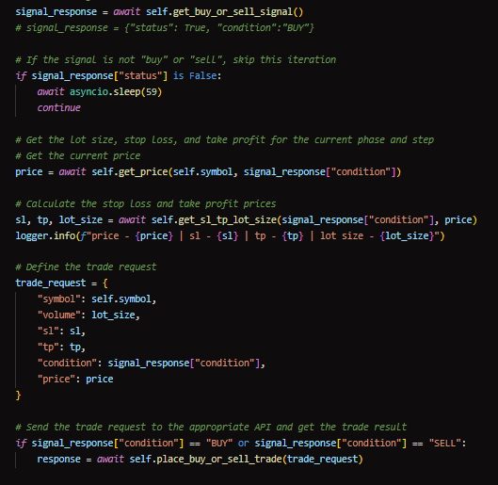

**Function:**

* The main method that manages the trading process.
* Continuously checks for open positions, places trades, and adjusts phases and steps based on trade outcomes.
* Runs in a loop to keep the trading system active.

### initiate_system Method

**21**

**Function:**

* Initiates the trading system by running the money_management method asynchronously.

This breakdown provides a detailed explanation of each block of code and its functions, making it easier to understand the automated trading system's structure and logic.

## Conclusion

Building Rell Trader involved tackling complex challenges related to parallel processing, real-time updates, and dynamic data management. Leveraging Django's robust framework, MetaTrader 5 feature packed library and integrating Celery with Redis resulted in an efficient and scalable trading system. This documentation provides a comprehensive overview of the development process, key features, and the solutions implemented to overcome challenges.

### Future Improvements

While the current implementation of Rell Trader is robust, there are always areas for improvement and enhancement:

1. **Advanced Trade Signal Algorithms:**

Incorporate more sophisticated trade signal algorithms and machine learning models to improve trade accuracy and profitability.

1. **User Interface Enhancements:**

Improve the user interface of the mobile app to provide a more intuitive and seamless user experience.

Add more customization options for users to tailor the system to their specific trading strategies and preferences.

1. **Integration with Additional Financial Markets:**

Expand the system to support trading in additional financial markets, such as stocks, commodities, and cryptocurrencies.

1. **Enhanced Security Measures:**

Implement additional security measures to protect user data and ensure the integrity of trade operations.

By continually refining and enhancing the system, Rell Trader can remain at the forefront of automated trading technology, providing users with a powerful and reliable tool for managing their investments.